# Import Expo Apps From Github

Expo versions are constantly evolving, and sometimes our old code won't run on the latest version. To get it working again, we need to rebuild our project with the latest NPM and Expo versions. I have used the latest version of expo on my github. So you can use it too.

As far as I know, you have already installed NodeJS, so you can directly update your NPM.  
Run this command in PowerShell to update NPM

Update NPM to latest version  
**npm install -g npm@latest**

remove Expo-cli package in our PC. Expo-cli is no longer used and can break our apps.  
**npm -g uninstall expo-cli –save**

**Clone my Github repository to your PC**  
You can use my github. (<https://github.com/firmansubhi/othree_tutorial>)  
  
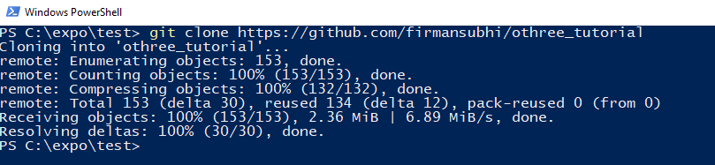

**Open your project folder with VS Code**  
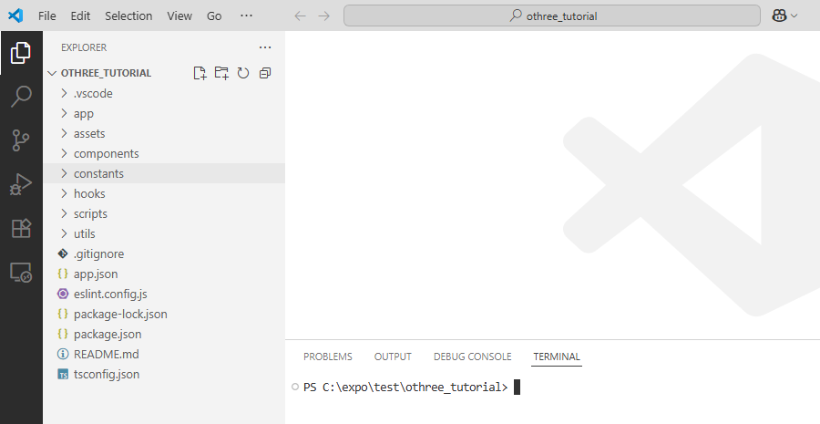

Type this command in VS Code terminal to install all required package  
**npm install**  
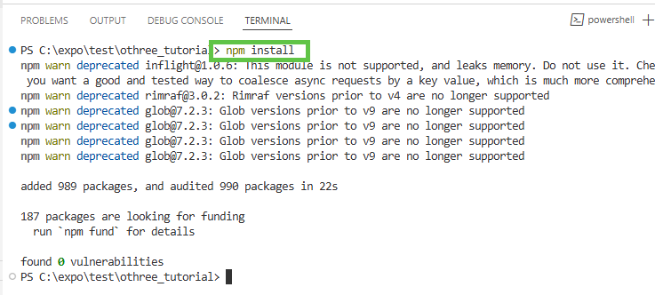

to adjust the package version to match the latest expo version, you can type this command in VS Code terminal.  
npx expo install –fix  
  
Run this project with this command.  
**npx expo start**  
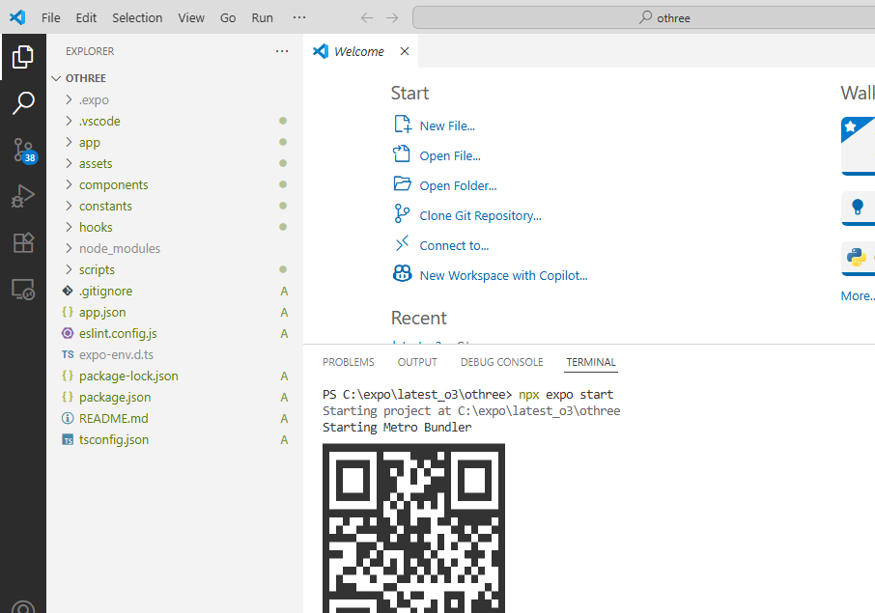

Install Expo Apps in your mobile phone.  
For android  
<https://play.google.com/store/apps/details?id=host.exp.exponent&hl=en>

For Appstore  
<https://apps.apple.com/us/app/expo-go/id982107779>

Scan QR Code with your Expo App, and the application should be able to run on your smartphone

# Create Expo Apps From Scratch

Update NPM to latest version  
**npm install -g npm@latest**

remove Expo-cli package in our PC. Expo-cli is no longer used and can break your apps.  
**npm -g uninstall expo-cli –save**

Create new expo project  
**npx create-expo-app@latest**

Ok to proceed?   
type **y**

What is your app named?  
Type **othree** (or whatever you want)  
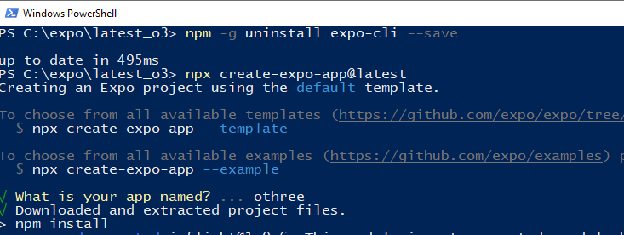

A new folder named **othree** will be created, open this folder with VS Code  
Run this project with this command.  
**npx expo start**

